iOS MapKit

Pooja Shah 010828311

Learning objective: Using Map Kit to plot a place mark and route between two points.

1. **App Design**

Application landing Page: Fig 1 shows the app landing page with asks for from location and To location.

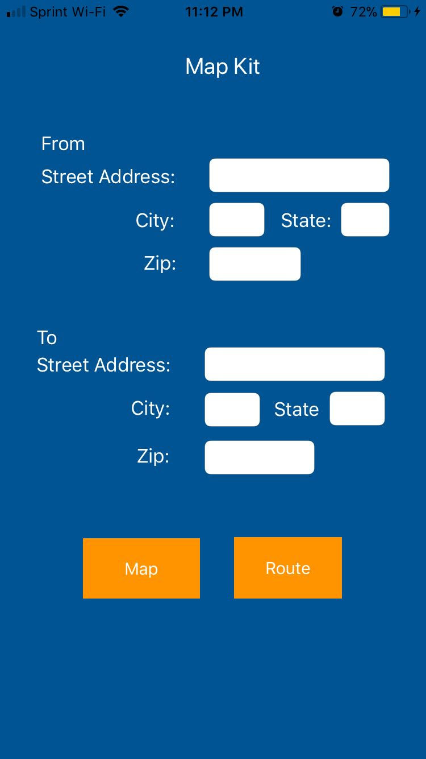

Fig 1. Application

Fig 2 shows the input values that can be entered in the application

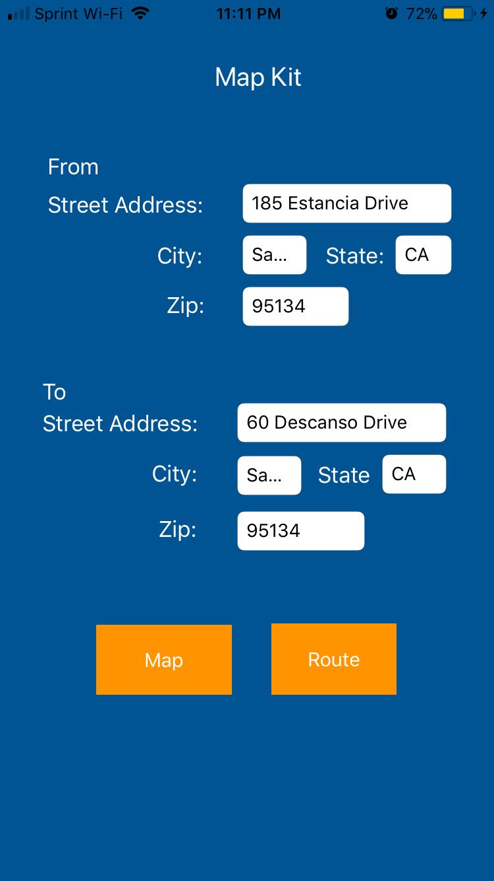

Fig 2. User Inputs

**Part 1 : Placemarker**

After clicking on “Map”, you can view the pins on the map. Fig 3 shows the pins that are placed for “From” location and “To” location

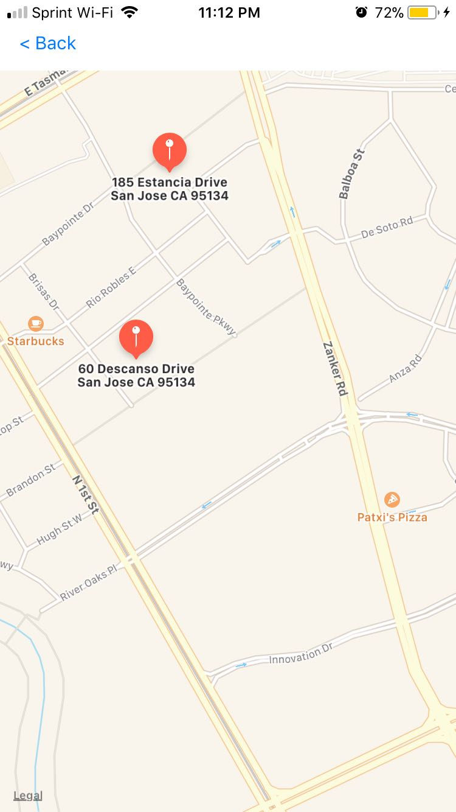

Fig 3. Location Placemarker

**Part 2 : Direction between places**

After clicking on “Route”, you can view the direction on the map. Fig 4 shows the direction drawn between “From” location and “To” location

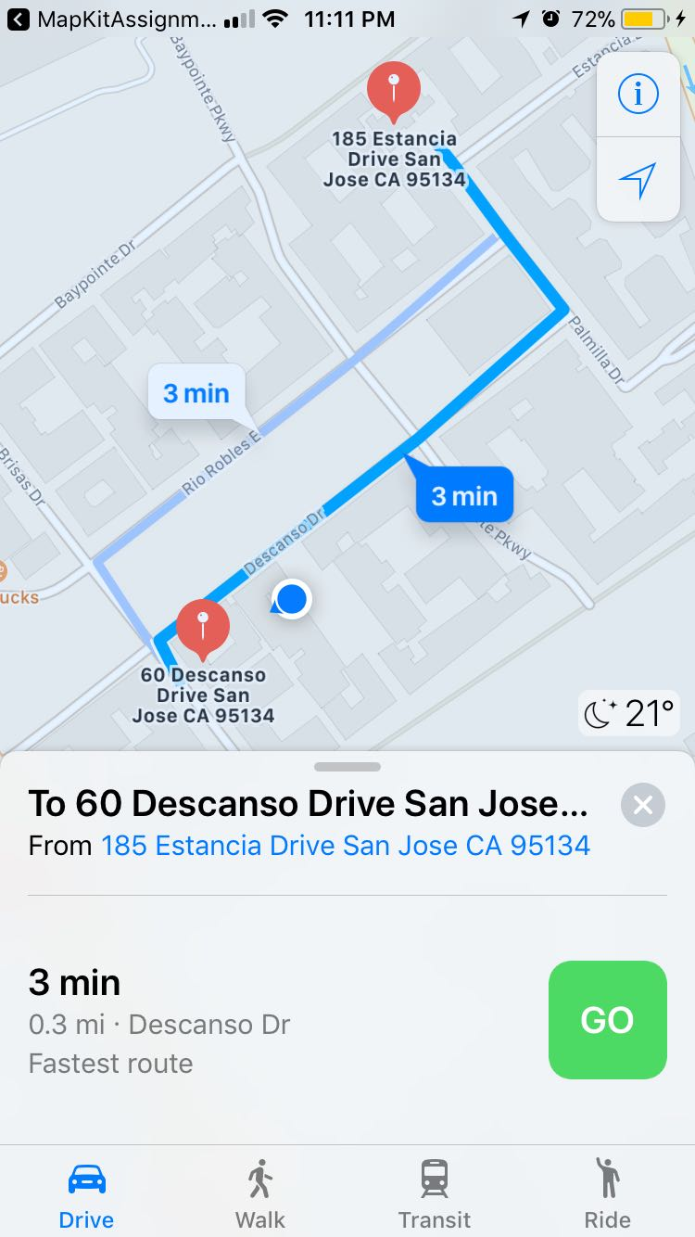

Fig 4. Route between 2 places

1. **Technologies**

Features and Kits used :

1. MapKit
2. Segue